Elite Warband Entries:
general Elite name
Ducat/Glory Symbols
just pictures aka small Screenshots
Headlines and Fancy stuff (Carol Gothic)
0-1 Name – Cost: 55
A Trench Pilgrim Warband must include 1 War Prophet
The wonderful custom Lore of this Lad. Lore titbits are in cursive (ctrl + i) and in a greyish colour.
Movement | Ranged | Melee | Armour | Base
6”/Infantry | +2 DICE | +2 DICE | 0 | 32 mm
Keywords (Artisan 12)
Normal Text (Garamond Pro / Times New Roman)
Battlekit | A ******* can have any Battlekit from the ******* Armoury Tables.
Abilities | - Ability Name ACTION: Abilities like this can be layed out in a table with white or without borders.  - secondary effect of the ability could be literally anything.  - further secondary effect
Special Bulletpoints | - Ability Name: Keywords are in all Caps and Bold (ctrl + b). DEMONIC, BLACK GRAIL, FIRE. Alternativly you could use Artisan 12 (a font included in the Dropbox) DEMONIC, BLACK GRAIL, FIRE
Keywords | PILGRIM, ELITE, LEADER
A Text Box with nested in the footer/header.
Select any Text and press (ctrl + k). If you have any text in your Document that is set as a Headline you can Link to it
Google Bookmark and link maybe for more infos
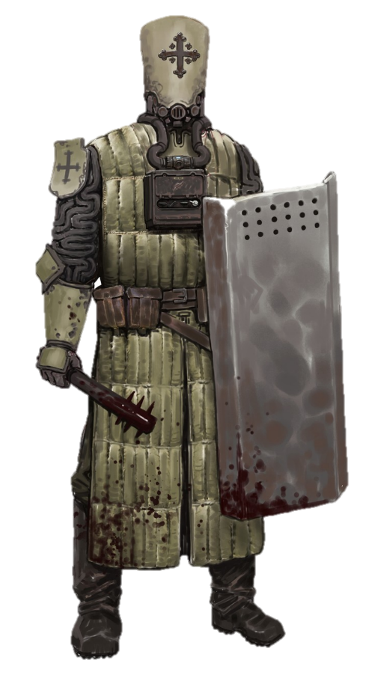
A png/jpg with its background removed,
try
https://www.remove.bg/
OR
Picture Format/Remove Background (in Word)
OR
Gimp/Photoshop
A Rectangle Shape with its “Line” set to 100% transparency, but also set to Sketched style
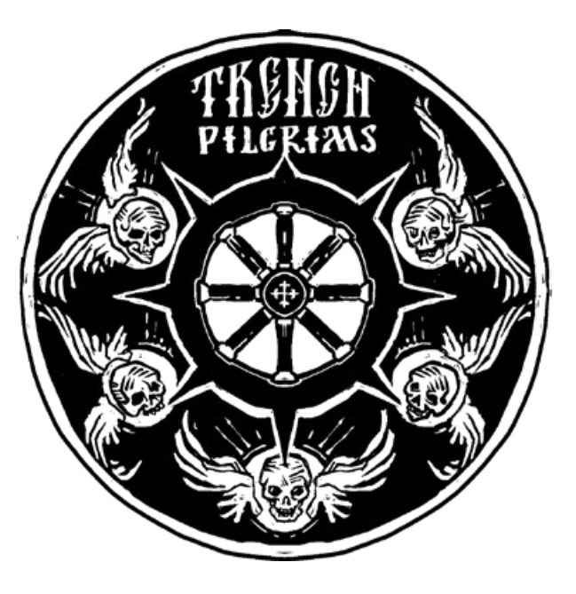

Trench Pilgrim

Lore goes here- - - - - - - - - - - - - - - - - - - - - - - - - - - - - - - - - - - - - LORE - - - - - - - - - - - - - - - - - - - - - - - - - - - - - - - - - LORE - - - - - - - - - - - - - - - - - - - - - - - - - - - - - - - - - - - - - - - - - - - - - - - - - - - - - - - - - - - - - - - - - - - - - - - - - - - - - - - - - - - - - - - - - - - - - - - - - - - - - THANK YOU - - - -FOR MAKING - - - -- - - -- - - -HOMEBREW - - - - - - - - - - - - - - - - - - - - - - - - - - - - - - - - - - - - - - - - - - - - - - - - - - - - - - - - - - - - - - - - - - - - - - - - - - - - - - - - - - - - - - - - - - - - - - - - - - - - - - - - - - - - - - - - - - - - - - - - - - - - - -LORE - - - - - - - - - - - - - - - - - - - - - - - - - - - - - - - - - - - - - - - - - - - - - - - - - - - - - - - - - - - - - - - - - - - - - -FEEL FREE TO - - - - - - REACH OUT IF YOU - - - - - - HAVE ANY - - - - - - - - - - - - QUESTIONS - - - - - - - - - - - - - - - - - - - - - - - - - - - - - - - - - - - - - - - - - - - - - - - - - - - -LORE- - - - - - - - - - - - - - - - - - - - - - - - - - - - - - - - - - - - - - - - - - - - - - -- - - - - - - - - - - - - - - - - - - - - - - - - - - - - - - - - - - - - - - - - - - - - - - - - - - - - - - - - - - - - - - - - - - - - - - - - - ARTILLERY WITCH - - - - - - - - - - - - - - - - SUPREMACY - - - - - - - - - - - - - - - - - - - - - - - - - - - - - - - - - - - - - - - - - - - - - - - - - - - - - - - - - - - - - - - - - - - - - - - - - - - - - - - - - - - - - - - - - - - - - - - - - - - - - - - - - - - - - - -I WOULD - - - -REALLY APPRETIATE IF YOU COULD CONSIDER LINKING TO THIS IF - - - -YOU ARE USING IT - - - - - - - - - - - - - - - - - - - - - - - - - - - - - - - - - - - - - - - - - - - - - - - - - - - - - - - - - - - - - - - - - - - - - - - - - - - - - - - - - - - - - - - - - - - - - - - - - - - - - - - - - - - - - - - - - - - - - - - - - - - - - - - - - - - - - -MORE - - - - - - LORE - - - - - - - - - - - - - - - -

Trench Pilgrims
Many of the devout see it as their sacred duty to make the pilgrimage to No Man’s Land and throw themselves at the forces of Hell with righteous wrath. These zealots band together into vast Pilgrim Processions, fighting an endless crusade against the blasphemous foe

Warband Creation
You have 700 to recruit a Trench Pilgrims Warband for a campaign (> see Starting a Warband). Trench Pilgrims are Faithful.

Special Rules
No special rules apply to a standard Trench Pilgrims Warband.

Armoury Tables
Trench Pilgrims can have the following Battlekit. Battlekit with a bullet point [•] is unique to Trench Pilgrims Warbands, and its rules can be found in the Trench Pilgrims Battlekit section after the Armoury. (▶ see Battlekit in the Trench Crusade Digital Rulebook).
Ranged Weapons
Automatic Pistol | Limit: 2 | 3
 |  Ducats  Glory | 25
 |  | 20
 |  | 2
 |  | 2

Grenades
•Automatic Pistol | Limit: 2 | 10
 |  | 25
•Special Grenade |  | 20
 |  | 2
 |  | 2

Shields
Automatic Pistol | Limit: 2 | 10
 |  | 25

Armour
Automatic Pistol | Limit: 2 | 10
 |  | 25
 |  | 20
 |  | 2
 |  | 2

Equipment
Automatic Pistol | Limit: 2 | 10
 |  | 25
 |  | 20

Your Faction Battlekit
The following Battlekit items are unique to the Trench Pilgrims Warband. Rules for all other items are in the standard Battlekit section (▶ see Battlekit in the Trench Crusade Digital Rulebook).

Holy Icon Shield | 2 | ELITE only
These shields are made from icons that have performed miracles. Mounted on blessed wood, they are harder than any steel and virtually indestructible. Only the most revered fighters in the service of the Church carry one
Type | Range | Keywords
Shield | - | -1 INJURY MODIFIER, IMPERVIOUS

Punt Gun| 20 | Limit: 2
A Punt Gun is an enormous shotgun loaded with up to 25 ounces of shot. It can be loaded with a risky amount of powder and square shot, which causes widespread damage and destruction. It is a very popular weapon among Trench Pilgrims who lack access to conventional heavy weapons.
Type | Range | Keywords
2-Handed | 18” | +1 DICE, +1 INJURY DICE, HEAVY, SHOTGUN, SHRAPNEL

- Overcharge: Before making a Ranged Attack with a model armed with a Punt Gun, you can say that the model will Overcharge the weapon. To do so, the model has to either have the STRONG Keyword or be in base-to-base contact with a friendly model. An Overcharged Ranged Attack gains the BLAST 3" and RELOAD Keywords. After an Overcharged attack has been carried out, place 1 BLOOD MARKER next to the model that made the attack, and its activation immediately ends.

Elite Warband Entries:
general Elite name
0-1 NAME – Cost: 55
A Trench Pilgrim Warband must include 1 War Prophet
The wonderful custom Lore of this Lad. Lore titbits are in cursive (ctrl + i) and in a greyish colour.
Movement | Ranged | Melee | Armour | Base
6”/Infantry | +2 DICE | +2 DICE | 0 | 32 mm

Battlekit | A ******* can have any Battlekit from the ******* Armoury Tables.
Abilities | - Ability Name ACTION: Abilities like this can be layed out in a table with white or without borders.  - secondary effect of the ability could be literally anything.
 | - Ability Name: Keywords are in all Caps and Bold (ctrl + b). DEMONIC, BLACK GRAIL, FIRE. Alternatively you could use Artisan 12 (a font included in the Dropbox) DEMONIC, BLACK GRAIL, FIRE
Keywords | PILGRIM, ELITE, LEADER



Troop Warband Entries:
The Faithful 
0-1 War Prophet – Cost: 55
A Trench Pilgrim Warband must include 1 War Prophet
The wonderful custom Lore of this Lad. Lore titbits are in cursive (ctrl + i) and in a greyish colour.
Trench Pilgrim Profile
Movement | Ranged | Melee | Armour | Base
6”/Infantry | +2 DICE | +2 DICE | 0 | 32 mm
Martyr Penitent Profile
Movement | Ranged | Melee | Armour | Base
6”/Infantry | +2 DICE | +2 DICE | 0 | 32 mm

Battlekit | A War Prophet can have any Battlekit from the Trench Pilgrims Armoury Tables.
Abilities | - Loudspeakers ACTION: A War Prophet can take a Loudspeakers ACTION. If they do so, take a Risky Success Roll for the model and add +2 DICE to the roll. If the roll is a Failure, the War Prophet’s Activation ends immediately. If the roll is a Success or Critical Success, you can move all friendly models within 8" of the War Prophet (including the War Prophet) up to 3". They must end the move as close as possible to the nearest enemy model that was visible to them at the start of the move. If no enemy models are visible, they can move normally
Keywords | PILGRIM, ELITE, LEADER
Punt Gun
The wonderful custom Lore of this Lad. Lore titbits are in cursive (ctrl + i) and in a greyish colour.
Type | Range | Keywords
2-Handed | 18” | +1 DICE, +1 INJURY DICE, HEAVY, SHOTGUN, SHRAPNEL
- Overcharge:  Ducats  Glory Before making a Ranged Attack with a model armed with a Punt Gun, you can say that the model will Overcharge the weapon. To do so, the model has to either have the STRONG Keyword or be in base-to-base contact with a friendly model. An Overcharged Ranged Attack gains the BLAST 3" and RELOAD Keywords. After an Overcharged attack has been carried out, place 1 BLOOD MARKER next to the model that made the attack, and its activation immediately ends.

Warband Variant

Procession of the Sacred Affliction
Trench Pilgrims of the Procession of the Sacred Affliction are known for their zeal in close-quarter combat, their armour decorated with icons and shields adorned with the depictions of the Saints, which, despite appearances, can withstand machine gun bullets. The millstones they carry upon their backs are used to tie about the necks of sinners before drowning them in the mud and blood of No Man’s Land. They spurn the use of the iron capirotes, believing firmly that faith alone is enough to withstand the horrors of Hell.
PROCESSION OF THE SACRED AFFLICTION SPECIAL RULES
The following special rules apply to a Procession of the Sacred Affliction Warband
- Hammer and the Anvil: Anti-Tank Hammers taken for a Procession of the Sacred Affliction Warband do not have the (ELITE only) restriction
- Face thy Fears: Models in a Procession of the Sacred Affliction Warband cannot have Iron Capirotes. Ecclesiastic Prisoners in a Procession of the Sacred Affliction Warband do not have Iron Capirotes, but their cost remains the same.

PROCESSION OF THE SACRED AFFLICTION

ARMOURY ß BATTLEKIT
The following special rules apply to a Procession of the Sacred Affliction Warband

Holy Icon Armour | 30
These shields are made from icons that have performed miracles. Mounted on blessed wood, they are harder than any steel and virtually indestructible. Only the most revered fighters in the service of the Church carry one
Type | Range | Keywords
Armour | - | -1 INJURY MODIFIER, IMPERVIOUS

